Kol Simcha Torah Gazette
For parshas vayeira 5785
Volume 9 Issue 8 (Whole #422) 15 Cheshvan 5785/ November 16, 2024
Printed L’illuy nishmas Nechama bas R’ Noach, a”h

For a free subscription, please forward your request to keren18@juno.com
Past emails can be found on the website ShabbosStories.com under Brooklyn Torah Gazette

Can a Rebbe Ever
Make a Mistake?
By Daniel Keren

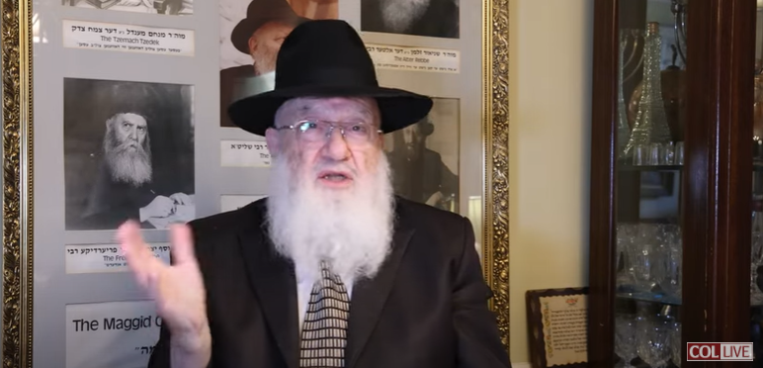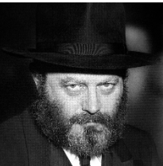
Rabbi Sholom Ber Schapiro and the Lubavitcher Rebbe

Can a Rebbe ever make a mistake? In particular the question has often been asked by outsiders to members of the Chabad Lubavitch community with regards to the late Lubavitcher Rebbe – Rabbi Menachem Mendel Schneerson, zt”l. And the response of the Rebbe’s followers to such a question has to be outrage that anyone could even think of such a possibility of an error by their Rebbe.
So, it was quite interesting to come across a recent podcast released this past Motzei Shabbos (Saturday night) by a highly respected insider of the Chabad community. The podcast’s (“Historic Treasures by Rabbi Sholom Ber Schapiro) most recent episode #218 dealt with that very question and was therefore titled “Can a Rebbe Ever Make a Mistake?”
This particular episode by Rabbi Schapiro focused on three seeming “mistakes” by the Lubavitcher Rebbe – (1) a marriage of a young man that ended in divorce, (2) a trip that didn’t go well and (3) forgetting where an important chasid of his lives.
Rabbi Schapiro began by bringing up the question of the many stories that have been told about Rabbi Schneerson, one of the most dynamic Jewish personalities of the 20th Century, whose legacy of leadership continues seemingly uninterrupted today by new Lubavitcher shluchim (emissaries) who had not even been born with the Rebbe was alive.

The Stories of the Baal Shem Tov
Can all of these stories of the Lubavitcher Rebbe possible be true? Rabbi Schapiro brought up a saying about the founder of the Chassidic movement – the Baal Shem Tov (Rabbi Yisroel ben Eliezer, 1698-1760), that if one believes that all of the (perhaps thousands of) stories told about the Baal Shem Tov are true, one is a shoteh (fool). On the other hand, if one declares that none of the Baal Shem Tov stories could ever be true, than such a person is nothing but an apikorsas (a heretic.)
Rabbi Schapiro noted in his podcast that similarly not all stories being told about the late Lubavitcher Rebbe are true. But like the Baal Shem Tov, all of the stories being told about the Lubavitcher Rebbe could have been true.
How can one determine whether a story about the Lubavitcher Rebbe is actually true? Rabbi Schapiro said that any story that he personally heard from Rabbi Nissan Mindel (1912-1999) could be verified as being absolutely true. Who was Rabbi Mindel? He was a prominent Chabad rabbi, author and editor who served on the administrative staff of the Lubavitcher Rebbe.

The Marriage that Ended in Divorce
The first seeming mistake of the Lubavitcher Rebbe that Rabbi Schapiro discussed in his podcast was that of a young man whose marriage ended in divorce. This occurred when the young man wrote in to the Rebbe to explain that he was going out with a young lady, but did not sense a “Hamshachas Halev,” a comfortable feeling about the shidduch. Rabbi Schapiro pointed out that having a “Hamshachas Halev,” was a very important concern to the Rebbe and he frequently would advise a young man or woman who wrote that they didn’t have such a comfortable feeling about their shidduch, to not continue with it.
But in this particular case, despite the young man’s lack of a “Hamshachas Halev,” the Rebbe advised him to continue with the shidduch. And so, the young man did so and yet he wrote again that he didn’t feel comfortable with asking the young woman to marry him. And again, the Rebbe ignored that concern and urged the young man to continue with the shidduch. The young man eventually proposed to the woman believing that the Rebbe wanted him to get married to her.
Unfortunately, a few years later, he wrote back to the Lubavitcher Rebbe that he was in the process of getting divorced and he had tainas (complaints) and was blaming the Rebbe for telling him not to break the shidduch when he had his serious doubts.
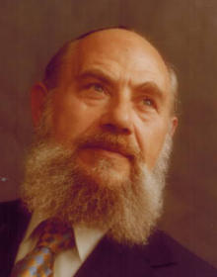
Rabbi Nissan Mindel

The Lubavitcher Rebbe asked Rabbi Mindel what he thought about the letter writer’s complaint and his associate wisely remained silent. Rabbi Schapiro in his podcast said that in a similar situation the Tzemach Tzedak (the third rebbe of Chabad, 1789-1866) was the mesader kedushin (conductor of the wedding ceremony) of a grandchild, whose marriage ended in divorce just three months later. He was asked how such a thing could happen if the holy Rebbe himself had given brochas (blessings) to the couple. The Tzemach Tzedek explained that a “mistake” by a tzaddik is not really a mistake. Rather, it is because the Abishter (our Father in Heaven) for reasons that we or even the Rebbe doesn’t know had to be.
Getting back to the story of the young man who was told by the Lubavitcher Rebbe to continue his shidduch even though he didn’t have a comfortable feeling about the young woman, Rabbi Schapiro in his podcast said that two and a half years later after their divorce, the couple remarried and had a number of children, moved to Eretz Yisroel and are very happy today. But for reasons that only the Abishter knows, that young man had to endure that initial divorce.
To learn about the trip that didn’t go well or about the Rebbe apparently forgetting where one of his trusted chassidim lived, you can view Rabbi Schapiro’s 15-minute podcast by clicking – YouTube – Can a Rebbe Ever Make a Mistake or by googling https://youtu.be/g71pC2uJa9Q?si=keyKdx3K8CmIIQrj

Reprinted from this week’s edition of The Jewish Connection.
Rav Avigdor Miller on
Praying for the President

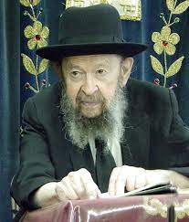
QUESTION: What do you think about the election of Carter to be our next President?
ANSWER: I haven’t the slightest knowledge about Carter. But I hope that Hakodosh Boruch Hu will give him His blessings and give him success. Now that he’s been elected, it’s a mitzvah to daven for Carter.
It’s a mitzvah. You have to be mispallel b’shlom malchus; every Jew has to pray for the benefit of the government. Now that he’s been elected, we daven he should be well; he shouldn’t catch a cold. He shouldn’t be bothered by the liberals. He shouldn’t have any wars in his time. And בימיו תושע יהודה וישראל ישכון לבטח (Yirmiyahu 23:6), in his time the Jewish people should be happy and prosperous and Moshiach should come. That’s the best I can tell you.
And that’s our duty, to pray for Carter. Every Jew has to pray for Carter. And you have to still pray for Ford by the way, because he’s still President until January. So for the duration of his term, you have to pray for him.
A Jew must pray for his government. It’s very important. It’s a mishna in Mesichta Avos (3:2); plain and simple we must pray for the government. And even if you haven’t done it till now, it’s a good time to begin. From now on think about it sometimes, and say it. Even when you’re on the street walking, say a little prayer for the President and for the Vice-president, and don’t be ashamed. Don’t worry that you might be ridiculed by somebody – let nobody know about it. But you should know that you’re doing the duty of an Orthodox Jew.


You must pray for the government! Not because you want to show the government that you pray for them. The fakers come together and wave flags, and they make an official prayer – that doesn’t mean a thing. They’re not praying for the government they’re just showing off. Pray for the government quietly between yourself and Hashem. And you should really mean it.
Have in mind that Carter should be well and that he shouldn’t have troubles. He shouldn’t fight with his wife. He should have peace at home and peace in the government. Congress should cooperate with him. There’s no question that if there will be a tranquil government, then Carter will try to make a good name for himself. No question about it. Any President would like to make a regime that will go down in history as a successful regime.
And so, our best wishes are given to the incumbent, President-elect Carter, and Hakodosh Boruch Hu should help him – and us.
TAPE # 144 (November 1976)

Reprinted from a recent email of Toras Avigdor (Tape #760, November 1989).

The Mitzvah of Visiting
A Jew on the Third Day
From the Teachings of the Lubavitcher Rebbe
Rabbi Menachem Mendel Schneerson, Zt”l

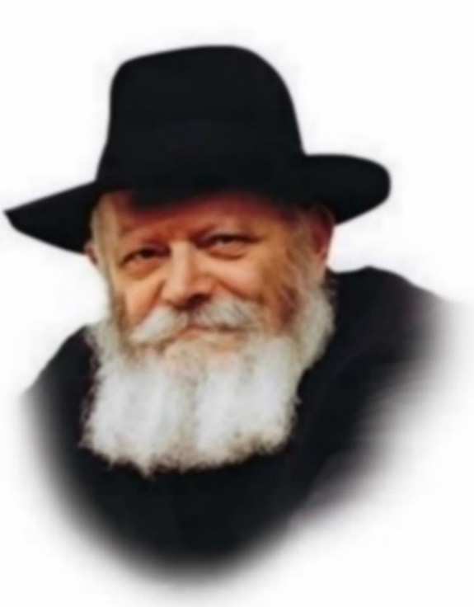

"And the L-rd appeared to him," we read in this week's Torah portion, Vayeira. "And he lifted up his eyes and saw three men." Citing the Talmud, Rashi explains: "It was the third day after his circumcision, and the Holy One, Blessed be He, came and inquired of his welfare."
From the fact that G-d visited Abraham when he was ill we learn that we too must perform the mitzva of bikur cholim, visiting the sick. Moreover, the Torah does not refer to Abraham by name (the verse states only "to him") to teach us that G-d visited him not because of his superior qualities or virtue, but simply because he was sick. It is a mitzva to visit any Jew who is not well.

How does the Talmud derive that G-d appeared to Abraham on the third day after his brit mila?
The Torah's commandments are intended to be performed within the natural order, as opposed to in a miraculous manner. The purpose of mitzvot is to refine the physical world and imbue it with sanctity and holiness. The preparations for doing a mitzva, as well as its results or consequences, must also be within the natural order.
There is a famous story told about the Rabbi Shneur Zalman of Liadi, founder of Chabad Chasidism, who was once traveling by boat when it came time to bless the new moon. The Alter Rebbe (as he is known) performed a miracle and brought the boat to a halt, but he did not recite the blessing until the captain agreed to stop the vessel. The Alter Rebbe's intention was that the preparation for the mitzva, i.e., stopping the boat, should also be carried out within the confines of nature.
Even if it is very difficult to do a mitzva, it is still meant to be performed within the natural order. For if the hardships were to be alleviated miraculously, it would detract from the mitzva's perfection.
Among the three angels who came to Abraham that day was Rafael, whose function is to heal. It is obvious that the angel would not have visited before the third day, as according to nature, a person who undergoes circumcision is considered sick for the first two days. It is inconceivable that G-d would have healed Abraham before then in a miraculous manner, as it would have detracted from the wholeness of his mitzva. As it is understood that the angel was not sent to alleviate the difficulties associated with the mitzva of brit mila, we know that his visit, and G-d's, was on the third day.

Reprinted from the Parshat Vayera 5762/2001 edition of L’Chaim. Adapted from Volume 5 of Likutei Sichot.

While he was sitting at the entrance
of the tent in the heat of the day.

Rashi says Because Hashem saw Avraham was upset that there were no visitors coming, He brought the angels to him in the form of men. Why was Avraham upset that there were no guests. The Mitzvah of Hachnosas Orchim is not one that you must go search out to do. It is a Mitzvah that one must do if the situation arises. And what did Avraham accomplish by entertaining the angels.
There is no Mitzvah of Hachnosas Orchim - to entertain angels. Avraham had two purposes in fulfilling the Mitzvah of Hachnosas Orchim. One was to fulfill the Mitzvah. The second was to inspire others with the characteristic and trait of Chesed. He wanted people to see him and learn from him this trait.
The Mitzvah of Hachnosas Orchim only applies if there are guests. There is no Mitzvah to seek out guests. But Avraham wished to seek out people so that he could have an influence on them. He was upset that there were no people around. So, Hashem brought him angels in the form of men. (Rabbi Shlomo Heiman)

Reprinted from the Parashat Vayeira 5785 email of R’ Yedidye Hirtenfeld’s whY I Matter parsha sheet for the Young Israel of Midwood in Brooklyn, NY.
Thoughts that Count
for Parshas Vayera

And he sat at the opening of the tent in the heat of the day (Gen. 18:1)
This is the mark of the true tzadik (righteous individual), who always sees himself "at the opening," i.e., the very beginning, along the path of righteousness. Considering himself still "outside" and far from spiritual perfection, he worries that his deeds haven't accomplished much... (Toldot Yaakov Yosef)

And he lifted up his eyes and behold, he saw three ("vehinei shlosha") men standing by him (Gen. 18:2)
The numerical equivalent of the Hebrew letters of "vehinei shlosha" is 701, the same as "eilu Gavriel, Michael u'Refael" - "these are Gabriel, Michael and Raphael" - the three angels who came to visit Abraham. (Baal HaTurim)

And they said, So do as you have said (Gen. 18:5)
The way of tzadikim is to say little, yet do much. The angels knew that Abraham was a tzadik, and that he would go out of his way - above and beyond what he had already offered - to make them feel at ease. They therefore asked him to "do as he had said" with regard to their comfort, and no more. (Torat Moshe)

For I know him...that he will do justice and judgment (Gen. 18:19)
What is the connection between justice and judgment? Whenever G-d gives a person an abundance of blessings, he must ask himself: Do I really deserve so much goodness? Why me and not someone else? This "self-judgment" will then prompt him to give tzedaka (charity) in a generous and unstinting manner. (Sefer HaMaamarim)

And he said...possibly ten will be found there (Gen. 18:32)
Why did Abraham say "possibly"? If there were ten righteous people in the city, isn't it logical to assume that he was acquainted with them? Rather, Abraham was concerned that there might be "hidden tzadikim" living in Sodom, who were afraid to reveal themselves as such in their wicked society. (Shoshanat Avraham)

Reprinted from the Parshat Vayera 5762/2001 edition of L’Chaim.

Reb Yossele Mishnah

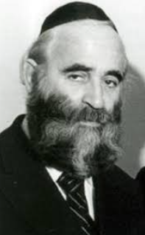
Rabbi Chaim Kreizwirth

Rav Chaim Kreizwirth zt”l, who later became the rav of Antwerp and a world‐famous gadol and talmid chacham, was already a rosh yeshiva in Warsaw and Krakow as a bachur of only 18 years old! As he was a bachur, he slept in the yeshiva building, even though he was one of the roshei yeshiva, but of course, he had his own room.
Once, he heard that there was a bachur from a small town who was coming to Warsaw for special treatments by a big doctor in the city. This bachur's name was Yossel, and he was blind. He was a very special bachur, and he memorized many mishnayos ba'al peh, which he constantly would review to himself. In fact, he was known as "Yossele Mishna"!
He would be in the city for a few days while the doctor tried to help him, and Rav Chaim decided that he would go to the train station to greet this special bachur, and help him get to the place he was staying at. Rav Chaim waited at the station, and when Yossele finally arrived, it was discovered that somehow there was a mix‐up and there were no sleeping arrangements made for Yossele!
Rav Chaim immediately said, “I know of an extra bed!” Rav Chaim took him to his own room, and led Yossele to his bed. “Here is a bed for you!” Rav Chaim set up for himself a place to sleep on the floor on the other side of the room.
As it turned out, the doctor began a series of treatments that were going to take several weeks or even months. Rav Chaim happily kept Yossele in his room, while he himself slept on the floor. No matter how the talmidim of the yeshiva tried to convince Rav Chaim to have Yossele sleep elsewhere, so that he – the Rosh Yeshiva – could sleep in a bed, nothing worked to make Rav Chaim give up this special mitzvah.
After a few months, Yossele finally returned to his hometown, and life got back to normal. But it didn’t remain that way too long. As the Nazis ym”s came into power, one day there was a commotion outside the bais medrash. A group of soldiers were coming towards the beis medrash! Often, the Nazis would storm into a shul or yeshiva, and take away the rabbanim or roshei yeshiva, or even kill them, without warning.
They entered the bais medrash. Everyone froze. The leader pulled out a paper and began calling out several names. Those who were called were commanded to go outside. The names of a few of the rabbeim were called out.
Then Rav Chaim heard the Nazi say, “Kreizvert!” Trembling, he stepped outside. A Nazi motioned him to the side of the building, indicating that he stand against the wall. As he stood there, another Nazi walked up and lifted his gun, aiming directly at Rav Chaim.
Rav Chaim began to say Shema, and daven with all his heart.
“Hashem,” he whispered, “in the zechus of all the Torah I’ve learned with such hasmadah…” The Nazi raised the gun to his eye.
“Hashem,” continued Rav Chaim, “In the zechus of all the talmidim to whom I’ve taught Torah with such dedication…” The Nazi’s finger slid onto the trigger. “
Hashem,” pleaded Rav Chaim silently, “in the zechus of Yossele Mishnah, and all I did for him…” At that very moment, the soldier slid his gun down, and quickly said, “Jew! I will shoot the gun and miss you on purpose. As soon as you hear the shot, run to that woods as fast as you can! I will need to shoot after you, so it will appear as if you ran away, but I will miss you. No matter what happens, keep running! If the others follow you, they will surely kill you!”
A shot rang out, and Rav Chaim felt a bullet whiz by him and hit the wall. He began to run and run through the woods, as shots rang out around him, and angry cries echoed through the trees. He kept running until it got dark.
Eventually, he survived the war, and went on to live for many more years (1918-2001), becoming a Gadol Hador. He would always say that he was certain that it was in the zechus of his kindness to Yossele Mishna that his life was saved.

Reprinted from the Parshas Lech Lecha 5785 email of Shabbos Chayeinu. Stories selected by Tzvi Schultz.
Argentinian President Swears In Jewish Foreign Minister With Words of Torah
By Tzali Reicher

President Javier Milei connects weekly parshah to Gerardo Werthein's diplomatic mission

After swearing in his new Minister of Foreign Affairs, Gerardo Werthein, over a Chumash, the president embraces the newly appointed minister. Photo courtesy of Office of the President of Argentina

Typically, government swearing-in ceremonies are solemn if predictable affairs. A few welcoming remarks might be shared to commend the incoming official, followed by the oath, confirmation and some photos.
But in Argentina last week, President Javier Milei, true to his unconventional style, departed from the usual formalities and brought a fresh twist to the confirmation ceremony of the Honorable Gerardo Werthein as the South American country’s new Minister of Foreign Affairs.
Werthein, previously Argentina’s ambassador to the United States, is a proud and active member of the Jewish community in Argentina, who frequented the Chabad center in Washington, D.C., during his term of service there. It thus followed that the swearing-in ceremony for his new position at Foreign Affairs was carried out over a Chumash, the Five Books of Moses in Hebrew.
“Mr. Gerardo Werthein, do you swear by G-d and by the homeland and on the Torah to faithfully and devotedly fulfill the position of Minister of Foreign Affairs, International Trade, and Religions, to which you have been appointed, and to uphold and enforce, as far as it depends on you, the Constitution of Argentina?” Milei asked as he led the ceremony.
After Werthein affirmed his acceptance and the pair shared a warm embrace, Milei diverted from customary closing remarks and continued:
“Since today we have moved away from the conventional and traditional format and the oath was taken on the Torah, I thought it pertinent to speak about the weekly parshah,” said the president, referring to this week’s Torah portion of Lech Lecha, at the beginning of which G-d commands the patriarch Abraham to leave his homeland for Israel and begin influencing the world towards G-dliness.
“The forces of heaven are sending you signals, Gerardo,” Milei continued. “It speaks of the beginnings of Abraham’s travels around the world, spreading the messages of the Creator. G-d tells him that he will have a lot of influence on the nations of the world and gave him an important responsibility to bring the messages of the Torah, of life and of freedom to the entire world.”
Milei concluded his presidential dvar Torah by quoting the [Lubavitcher] Rebbe—Rabbi Menachem M. Schneerson, of righteous memory: “As the Rebbe would often say, we wish you blessings and success.”

‘The Rebbe’s Message Is Central to His Worldview’
While it might be surprising to some to see the Roman Catholic president sharing a timely thought on the weekly parshah, it comes as no shock to those who have been observing the unconventional political outsider since he swept to the top of Argentine politics a few years ago.
Milei has a long and exceptionally warm connection with Judaism and the Jewish community, stemming from his deep admiration of the Rebbe.
The president frequently cites the Rebbe’s teachings and ideas from the Torah and famously burst into tears when visiting the Western Wall in Jerusalem last year. On his first international stop after being elected president, Milei traveled to New York and made a point of praying at the Ohel, the resting place of the Rebbe, with his close friend and now Minister of Foreign Affairs Werthein at his side. It was Milei’s fourth visit to the holy site. A previous visit—made just months before his election—saw the former media personality fly to the U.S., pray at the Ohel and tour the headquarters of the Chabad-Lubavitch movement at 770 Eastern Parkway.
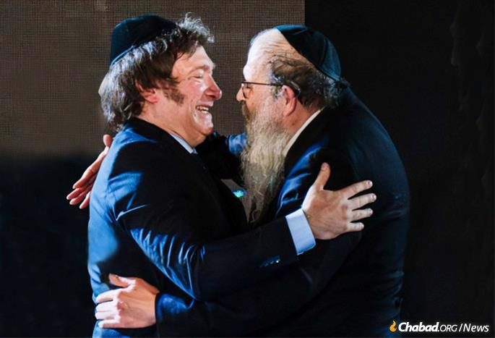
Milei with Rabbi Tzvi Grublatt, director of Chabad
Lubavitch of Argentina Photo: Chabad of Argentina

Wearing his trademark kippah, Milei also participated in Chabad Lubavitch of Argentina’s annual Chanukah event in 2023, only days after his inauguration, proudly declaring Argentina’s support for Israel and sharing the Rebbe’s teaching that the lesson of Chanukah is that “light prevails over darkness.” The ceremony was attended by thousands and broadcast on national TV.
“I think it’s a blessing to have a president who is a believer and values the timeless teachings of the Torah. We as a movement remain entirely apolitical, but it’s clear that this is positive for the nation,” Rabbi Tzvi Grunblatt, regional director of Chabad Lubavitch in Argentina, told Chabad.org. “While there are many leaders from various parties who also hold strong beliefs, what sets this president apart is his courage and natural ability to speak openly about his faith. He believes it’s the right thing to do, and he isn’t swayed by public opinion. In a time where so much is driven by what’s popular, he speaks about his faith because he genuinely believes in it, not for any political gain.”
This was reflected earlier this year when Milei made a low-key appearance at a Buenos Aires event marking 30 years since the Rebbe’s passing. Arriving with no entourage or fanfare, Milei sat anonymously in the bleachers and stayed for the entire two-hour event, paying tribute to the Rebbe not as president of Argentina but as a humble student and admirer of his life and work.
“The teachings of the Rebbe have had a profound impact on the president’s spiritual perspective and vision for the world,” Rabbi Grunblatt adds. “There’s no question about it—although he draws wisdom from many Torah sources—the Rebbe’s message is deeply significant and central to his worldview.”

Reprinted from the current website of Chabad.Org

